John Pilger Interview: White Australians Would Like Aboriginal People to Disappear
Sunday, 18 January 2015 00:00 By Mark Karlin
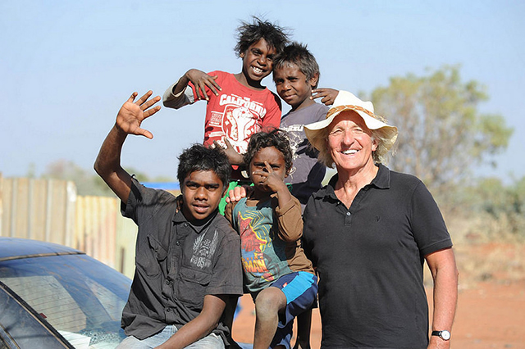John Pilger (right) working on the documentary Utopia. (Photo: Bullfrog Films)
Noted journalist John Pilger directed and is the lead investigator in an extraordinary documentary, Utopia: An Epic Story of Struggle and Resistance.
Pilger incisively and tenaciously reveals the brutal conquest and continued racist treatment of the Aboriginal people in Australia. Against this appalling historical documentation of conquest, discriminating and neglect, Pilger also highlights the continued resistance of the original inhabitants of the land stolen by British settlers.
You can obtain the 2-disc DVD set now with a contribution to Truthout by clicking here.
The following is a Truthout interview with John Pilger about Utopia.
Mark Karlin: Needless to say, one understands the irony of titling the film Utopia from very near the beginning of the documentary. Can you provide some details about the town and area and what you show of its abject neglect in the film?
John Pilger: The irony of Utopia isn't mine. It's the name given a vast, forbidding expanse of Australia's north by the British. What did they imagine? Perhaps, demented by the ferocity of the heat and dust, they intended to turn it into an English garden. More realistically, they understood that great wealth lay beneath the land. Certainly, their disregard for the people who had lived there for thousands of years - arguably the longest continuous human community - was typical of the attitudes that came with the colonial invasion of Australia. The indigenous people were at one with the harshness of the land; they knew where to find water and food; this was their physical and cultural home.
For more than two centuries, white Australians have tried to expel them - they've driven them into fringe camps, corralled them in reserves, stolen their children, imposed cruel and petty rules. Denied basic services most Australians take for granted, the people of Utopia suffer the kind of deprivation and disease associated with Africa; for example, Aboriginal children go blind from trachoma, a preventable disease eradicated in many third world countries. White Australia would like them to disappear; the First Australians not only refuse to disappear, they resist, often heroically.
There were so many horrifying details of daily life in Utopia, but I couldn't help but become physically queasy when a person charged with trying to improve life at the settlement talked about commonly finding cockroaches in the ears of aborginal people. How did you react to this revelation?
Yes, that's not uncommon. Many of the children in these communities suffer from otitis media, an ear infection that leads to deafness. It's a disease of extreme poverty. You ask about my reaction. As one born and brought up in Australia, my reaction is always a mixture of anger and shame.
Can you provide us with some historical context to the conquest of the Aboriginal people in what is now known as Australia Day and how to this day the nation of Australia has not acknowledged the native ownership of the continent by First Nations' peoples?
On January 26, 1788, a British naval fleet of ships, known as the First Fleet, dropped anchor in what is now Sydney Harbor. Australia was to be a penal colony following Britain's loss of its American colonies. The poor, the petty criminal, the rebellious of England and Ireland would be sent to the end of the earth - my great-great grandparents were among them, convicted of 'uttering unlawful oaths.'
The victims soon included the native people, whose land was appropriated. Indigenous people all over the world share a common suffering as a result of colonialism and immigration. This is not to deny there have been hard-won advances. For example, the High Court of Australia has acknowledged "Native Title" - prior ownership - but it's a paper recognition over which the great mining companies operate an effective veto.
You offer excellent interviews with Australian government officials who claim that it is - more or less - "a new day" for Aboriginal people in the nation, but your film directly disproves those assertions. Were you surprised at their brazen assertions?
No, I am never surprised by the lies and cynicism of those who watch over the designs of colonialism - in Australia, anywhere.
Can you briefly describe the so-called "emergency " government intervention that occurred in the "Northern Territory National Emergency Response" under the government of Prime Minister John Howard in 2007? It was so racist and such a cover for government control of Aboriginal land that might have minerals that it represented much of Canberra's mistreatment of the people that they conquered.
This was presented by John Howard as a vote-gaining crusade to "save" indigenous children from pedophiles in their communities, which were said to be operating in "unthinkable" numbers. It was a political con on such a scale that I suspect it could have happened only in Australia. The principal allegations were found to be baseless by the Northern Territory Police, the National Crime Commission, the Central Australian medical specialists' association, even by the author of a report whose recommendations the government claimed it was acting upon. The media played a central, shameful role, as the film reveals.
You spend a good deal of time on the theft of Aboriginal children in a government attempt to integrate them into European-centric culture. This is called the "stolen generation," but you contend the seizure of Aboriginal babies is still occurring, even in hospitals just after they are born, is that right?
Official statistics show that more Aboriginal children are being taken from their families and communities than at any time in Australian history. In the state of New South Wales, 10 percent of indigenous children have been taken, many of them placed with white families and unlikely to see their mothers and communities again. This is assimilation and little different in principle from the crude paternalism of the 19th and 20th century, which, in the infamous words of one official, sought to "breed out the color" of Australia's First People.
Similar to most colonial conquests, the Aboriginal people were considered subhuman, often killed and imprisoned. The lucky ones were just ignored to live, if they could survive, in the arid and beastly hot interior of the nation.
There is another, insidious element. A very small but significant section of Indigenous Australia has been co-opted by white authority - rewarded with education and bureaucratic largesse. This has produced a "transmission" colonial class of the kind that Franz Fanon wrote about and which oversees a divide-and-rule policy that ensures the majority remain at or near the bottom.
In 1901, the first prime minister of Australia, Edmund Barton, led the passage of what became known as "the White Australia Policy." The Immigration Restriction Act 1901 was based on what an Australian MP at the time said: "William McMillan spoke about the desire 'to prevent any alien or servile races from so occupying large territories in Australia, as to mix and interfuse, not merely among themselves, but with our own people. " (That's a quotation from the Australian Parliament website.) Where does Australia legally stand today, and where does it stand in fact?
The White Australia Policy is long gone; officially, there is no race discrimination in Australia. Certainly, in my lifetime the composition of the immigrant society has changed from that of predominately Anglo-Irish to one of the most multicultural in the world. Yet, racism runs like a current through much of Australia. Ask any indigenous person. They will often describe what amounts to a human contempt for them, for the truth of their past and their culture. At the very least, many Australians display an invincible ignorance of the one human feature of their country that is unique: the original people.
You have a segment in the film where you interview white Australians celebrating the nation's birthday. The range of responses to you asking the party-goers about the conquered indigenous population ranges from befuddlement to outrage at your question. From that random sample, the plight of the Aboriginal people appears to be a topic that spoils the fun, doesn't it?
That's a concise way of putting it.
You've done other documentaries on the plight of the aborigines, the racist superciliousness and indifference of the Euro-centric descendants, and the utter blighted existences of most aborigines. Has anything changed over the years that you have been covering this racial discrimination in your native Australia?
Australia remains a vivid expression of the way colonial power - from the 18th century to the present-day - regards and treats those whose land it steals. I made a film about the Native Americans, and the similarities are striking. My own belief is that until we, the colonizers and the immigrants, give back the nationhood of those whose lives our forebears so disrupted and destroyed, we can never claim our own.

Mark Karlin
Mark Karlin is the editor of BuzzFlash at Truthout. He served as editor and publisher of BuzzFlash for ten years before joining Truthout in 2010. BuzzFlash has won four Project Censored Awards. Karlin writes a commentary five days a week for BuzzFlash, as well as articles (ranging from the failed "war on drugs" to reviews relating to political art) for Truthout. He also interviews authors and filmmakers whose works are featured in Truthout's Progressive Picks of the Week. Before linking with Truthout, Karlin conducted interviews with cultural figures, political progressives and innovative advocates on a weekly basis for ten years. He authored many columns about the lies propagated to launch the Iraq War.

Related Stories
Indigenous Groups Challenge Doctrine of Christian Discovery and Domination
By Jason Coppola, Truthout | News Analysis
Indigenous Nations Are at the Forefront of the Conflict With Transnational Corporate Power
By Kevin Zeese and Margaret Flowers, Truthout | Op-Ed
Australia Is Again Stealing Its Indigenous Children
By John Pilger, Truthout | News Analysis

http://www.truth-out.org/progressivepicks/item/28572-john-pilger-interview-white-australians-would-like-aboriginal-people-to-disappear

